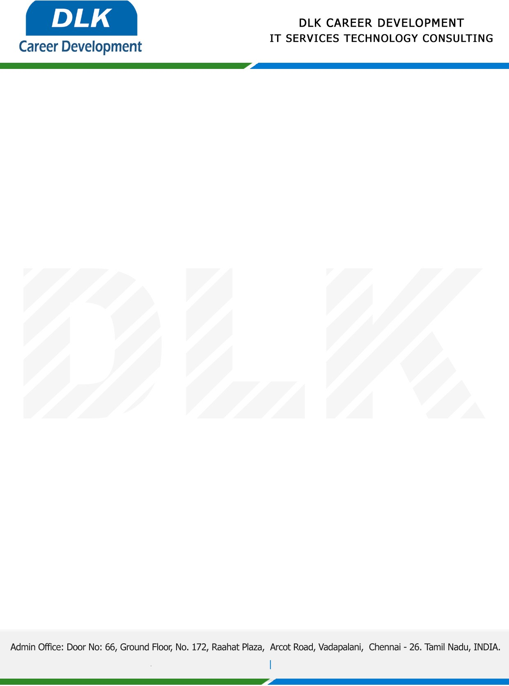

**Date: 03/May/ 2023**

**SUB: PROJECT COMPLETION CERTIFICATE**

This is to certify that **MS YAMINI A (REG NO:** **832100574)** **MSC-Computer Science,** final year student at **Shri Shankarlal Sundarbai Shasun Jain College for**

**Women** has successfully Completed her Project Work under the domain of “**PYTHON”** in our organization during the Period **(01st December 2022 to 29th April 2023)**

**Topic**: Analysis of women safety using Twitter data

We appreciate your interest in **DLK CAREER DEVELOPMENT**

**“Best Wishes for Your Future Endeavors “**

